Digital Rockwell Hardness Tester, Model: VSLIC-DRH

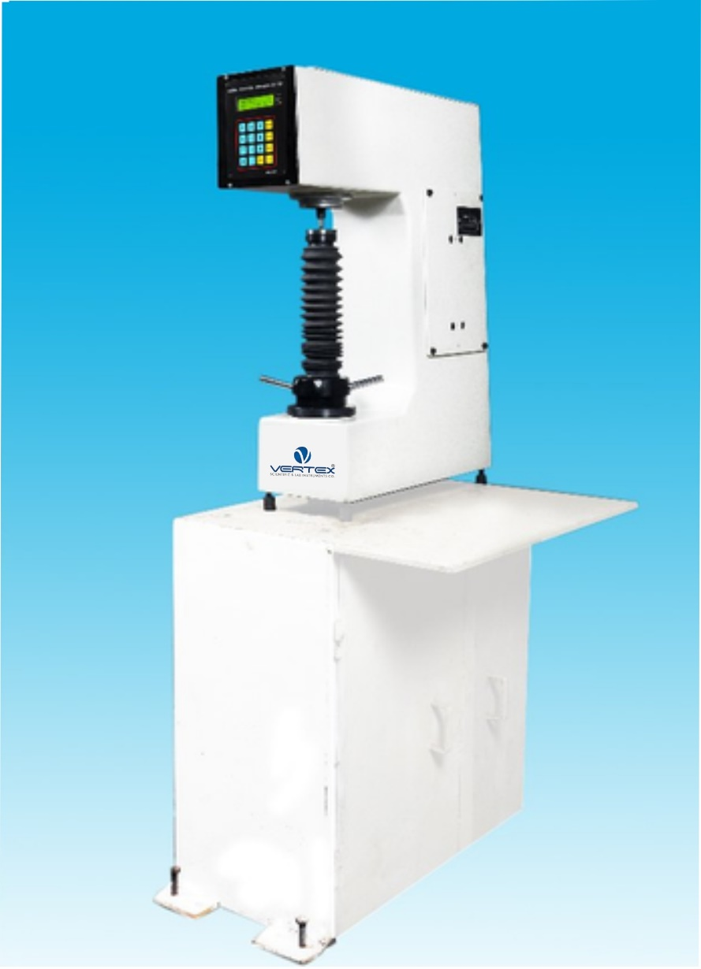

TECHNICAL SPECIFICATION of VERTEX’ make Digital Rockwell Hardness Tester, Model: VSLIC-DRH
Hardness Testing Machines Series – VSLIC-DRH

Hardness Testing Machines Series – VSLIC-DRH (For Rockwell, Rockwell Superficial & Brinell Testing)

Principal:
Rockwell, Rockwell superficial & Rockwell cum Brinell tests consists of forcing an indentor (Diamond or Ball) into the surface of a test piece in two steps i.e. first with preliminary test force and thereafter with additional test force and then measuring depth of indentation after removal of additional test force (Remaining preliminary test force active) for measurement of hardness value.

VSLIC-DRH series machines are suitable for Rockwell, Rockwell superficial & Rockwell cum Brinell tests. These are motorized digital Hardness testers having LCD display for easy hardness measurement. The results are displayed in 0.1 Rockwell unit for more accurate measurement.

Operation:
Various parameters of test can be set on front panel by operation of key board and observing LCD display Viz high/low limits, dwell time, auto/manual start, scale selection etc. All set data can be verified edited by pressing SCL key one after another.
Machine operation is very simple. The normal mode is a bar followed by "SET" indication. Raise elevating screw slowly through bar indication till "SET" position which will show "PRESS START" indication. Now press "START" button. Loading/unloading cycle will be completed and hardness is shown on LCD display with High/Good/Low indication. Lower down elevating screw. Panel will show normal mode for next test. Also when required 'AUTO START' on front panel by operation of key board & observing LCD Display then raise elevating screw slowly through bar indication till "SET" position then it will starts loading/unloading cycle automatically & hardness is shown on LCD Display with High/Good/Low indication.

Vertex's new 'VSLIC-DRH' series of Hardness Testing Machines come with much improved design & look with following major design changes.
- This is motorized machine having automatic loading/unloading cycle suitable for production testing.
- The machine body is having a taper front look and a large size read-out in the front. The paint shade does not fade and machine looks like new over year.
- The elevating screw of machine is guided in a hardened and ground bush, not allowing movement of elevating screw when raised to full height. The accessory is retained for years together due to hardened bush.
- A hardened and ground stepped bush is fixed on top of main screw for location and rest surface. This guarantees no change in results due to rough handling of test table or test piece. It means a trouble-free long-life machine accuracy.
- An antifriction linear bearing with almost no clearance is provided for a perfect vertical movement of loading plunger with minimum friction. This enables testing of small dia. samples.
- These models are provided with automatic working cycle and digital LCD display with 0.1 Rockwell resolution. This insures productivity with better accuracy.
- IS: 1586:2000 for Rockwell and superficial test.

Technical Data:

Model | Unit | VSLIC-DRH
Major Load | N (kgf) | 1471 N  (150 kgf)
Minor Load | N (kgf) | 98.07N (10 kgf)
Max.Test height | mm | 230
Depth of throat | mm | 133
Net wt. Approx. | kg. | 77
M/c Dimensions | mm | L-450, W-175, H- 627

Model | VSLIC-DRH
Type | Digital Rockwell
Operation Cycle | Automatic Load/Dwell/Unload
Preliminary Test Force | 98.07N (10 kgf)
Additional Test Force | 490.3, 882.6, 1373N  (50, 90, 140 kgf)
Total Test Force | 588.4, 980.7, 1471N  (60, 100, 150 kgf)
Test Force Selection | By external dialing
Set Position | With LCD bar indicator
Key Board Entry | Through membrane switches for scale, GO-No GO & dwell time selection
Resolution | 0.1 Rockwell
Output | Parallel output for connecting Dot Matrix Printer to get results indicating serial no. of tests, hardness scale, hardness value & high/good/low indication
Optional | Serial PD interface & windows software

Standard Accessories:
Model | VSLIC-DRH
Testing Table 50mm dia. | 1
Testing Table 38mm dia. with 'V' groove for round jobs 6-45 mm dia. | 1
Diamond indenter - Rockwell RA | 1
Diamond indenter - Rockwell SF | -
steel Ball Indenter 1/16" with 5 spare balls | 1
steel Ball Indenter 2.5 mm with 5 spare balls | -
Test Block Rockwell "C" | 1
Test Block Rockwell "B" | 1
Test Block HB 2.5 / 187.5 | -
Test Block HR 30 N | -
Allen Spanners | 5
Wooden Box for Std. Accessories | 1
Power Cable | 1
Brinell Microscope | -
Instruction Manual | 1

